NIH Article Processing Charge (APC) Policy Impact Analysis
The National Institutes of Health (NIH) is considering significant changes to allowable publication costs through a Request for Information (RFI) that could substantially impact Northwestern University's research publication expenses. Analysis of Northwestern's publication data reveals potential uncovered charges ranging from $3.3 million to $43.8 million over five years depending on the APC cap implemented, with response deadline of September 15.
Key Takeaway: All proposed NIH options will shift significant APC costs to Northwestern University, requiring immediate strategic planning and potential policy response.
What we see as possible risks for Feinberg:
- Costs shift to universities: All current NIH options under consideration in the RFI ultimately shift some APC costs onto institutions, which will indirectly divert university funds away from research activities.
- Financial exposure for NU: Since we don’t know exactly which direction the policy will go, we don’t have a detailed forecast, but the resulting impact is unlikely to be small. If any current NIH approach advances, we could face rapid, significant cost increases for APCs.
- Compounding issues: Even if NIH does not cap APCs, we are already seeing publishers effectively pushing NIH-funded articles toward fee-based OA.
See updated code, underlying data, and resulting spreadsheets by journal/publisher/summary: https://github.com/kglibrarian/Galter_NIH_Public_Access_Policy

Transformative Agreements: Zeroed out APC costs from ISSNs that fall within the Springer Nature and Wiley agreements (even though the Wiley agreement began in 2023 and the Springer Nature agreement began in 2025).
  - Had those waivers been in effect since 2020 through present, they would have applied to 2,418 papers with for a total of $9,435,824.
  - Zeroing out the APC costs for those ISSNs can be misleading because Northwestern IS covering those costs through the read/publish agreements via the library.

Financial Impact Analysis
For 2020-2025, the final dataset contains 12,211 unique publications (from 27,474 publications across 4,417 funded core projects; 12,903 duplicates removed; 2,360 without APC data excluded). Includes the 2,418 APC-waived publications but with $0 toward total costs.
Northwestern publication data from 2020-2025 and APC data from 2025:
- Option 1: The NIH disallows all publication costs.
  - 2,512 papers (effectively the 2,418 papers with waived APCs and 94 papers with APCs at $0) from a total of 496 journals fall within the “no allowable publication costs” cap
  - 9,699 papers from 1,226 journals that would not be covered
  - Total uncovered charges (consider the NIH pays $0 APCs from any journal) is $43,825,107.28
- Option 2: The NIH caps APC charges per paper at $2,000.
  - 2,970 papers from 565 journals that were fully covered by the cap (which includes the 2,418 papers with waived APCs),
  - 9,241papers from 1157 journals that would not be fully covered by the cap (i.e. have APCs higher than $2,000)
  - Total uncovered charges (consider the NIH pays the first $2,000 of an APC from any journal) is $24,577,857.28
- Option 3: The NIH caps APC charges per paper at $3,000
  - 4,261 papers from 771 journals that were fully covered by the cap (which includes the 2,418 papers with waived APCs),
  - 7,950 papers from 951 journals that would not be fully covered by the cap (i.e. have APCs higher than $3,000)
  - Total uncovered charges (consider the NIH pays the first $3,000 of an APC from any journal) is $ 15,770,528.28
- Option 4/5: The NIH caps APC charges per paper at $6,000 (only a partial model – see NIH RFI for full details!)
  - 11,093 papers from 1,627 journals that were fully covered by the cap (which includes the 2,418 papers with waived APCs),
  - 1,118 papers from 95 journals that would not be fully covered by the cap (i.e. have APCs higher than $6,000)
  - Total uncovered charges (consider the NIH pays the first $6,000 of an APC from any journal) is $ 3,348,456.6

Option | APC Cap_usd | Papers Covered | Papers Not Covered | Total Uncovered Charges | NIH Payments_usd
Option 1 | 0 | 2,512 | 9,699 | $43,825,107 | 0
Option 2 | $2,000 | 2,970 | 9,241 | $24,577,857 | $19,247,250
Option 3 | $3,000 | 4,261 | 7,950 | $15,770,528 | $28,054,579
Option 4/5* | $6,000 | 11,093 | 1,118 | $3,348,457 | $40,476,651

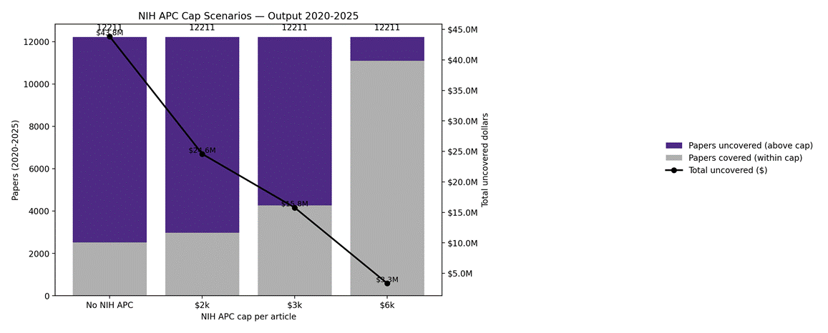
*Note, our version of “Option 4/5” is only partially modeled after what the NIH is suggesting

For 2024, the final dataset contains 2,033 unique publications (from 4,611 publications across 4,417 funded core projects; 2,052 duplicates removed; 526 without APC data excluded). Includes the 392 APC-waived publications but with $0 total costs.

Northwestern publication data from 2024 and APC data from 2025:
- Option 1: The NIH disallows all publication costs.
  - 402 papers (effectively the 392 papers with waived APCs and 10 papers with APCs at $0) from a total of 192 journals fall within the “no allowable publication costs” cap
  - 1,631 papers from 615 journals that would not be fully covered by the cap
  - Total uncovered charges (consider the NIH pays $0 APCs from any journal) is $ 7,490,803.91
- Option 2: The NIH caps APC charges per paper at $2,000.
  - 476 papers from 2,295 journals that were fully covered by the cap (which includes the 392 papers with waived APCs),
  - 1,557 papers from 578 journals that would not be fully covered by the cap (i.e. have APCs higher than $2,000)
  - Total uncovered charges (consider the NIH pays the first $2,000 of an APC from any journal) is $ 4,252,368.91
- Option 3: The NIH caps APC charges per paper at $3,000
  - 698 papers from 322 journals that were fully covered by the cap (which includes the 392 papers with waived APCs),
  - 1,335 papers from 485 journals that would not be fully covered by the cap (i.e. have APCs higher than $3,000)
  - Total uncovered charges (consider the NIH pays the first $3,000 of an APC from any journal) is $ 2,769,449.91
- Option 4/5: The NIH caps APC charges per paper at $6,000 (only a partial model – see NIH RFI for full details!)
  - 1,824 papers from 757 journals that were fully covered by the cap (which includes the 392 papers with waived APCs),
  - 209 papers from 50 journals that would not be fully covered by the cap (i.e. have APCs higher than $6,000)
  - Total uncovered charges (consider the NIH pays the first $6,000 of an APC from any journal) is $ 615,349.2

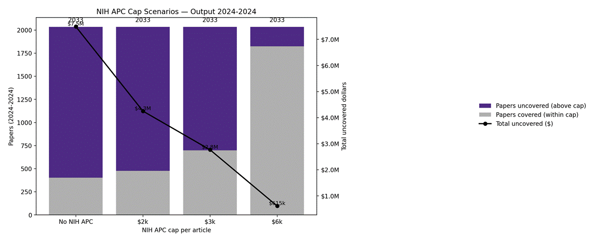

Option | APC Cap_usd | Papers Covered | Papers Not Covered | Total Uncovered Charges | NIH Payments_usd
Option 1 | 0 | 402 | 1,631 | $7,490,804 | 0
Option 2 | $2,000 | 476 | 1,557 | $4,252,369 | $3,238,435
Option 3 | $3,000 | 698 | 1,335 | $2,769,450 | $4,721,354
Option 4/5* | $6,000 | 1824 | 209 | $615,349.2 | $6,875,455

*Note, our version of “Option 4/5” is only partially modeled after what the NIH is suggesting
Reference(s):
NIH explores capping APCs: Let’s look at the evidence https://www.scholcommlab.ca/2025/09/03/nih-apc-caps/

“…..it makes one conclusion unmistakably clear: there is a significant gap between what the NIH is proposing as reasonable caps and the substantially higher charges imposed by publishers of journals where NIH-funded authors most frequently publish. This gap is likely even greater than our analysis indicates, since prior to the zero-embargo of the new policy, some authors included in the data had not paid APCs but instead complied by depositing their articles in PubMedCentral at no cost (green OA).”

